Homework Assignment 5

Zach Kushnir - 4367785

1. Weighted NN
   1. Matlab code
   2. As shown on the table, a value of 0.05 yields the highest accuracy of 0.72. as sigma gets less than and more than 0.05, the accuracy decreases.

|  |  |  |  |  |  |  |
| --- | --- | --- | --- | --- | --- | --- |
| Sigma | 0.01 | 0.05 | 0.2 | 1.5 | 3.2 | 5 |
| Accuracy | 0.68 | 0.72 | 0.68 | 0.68 | 0.64 | 0.56 |

2.0- Data Processing

a. image:

ps5-2-0.png

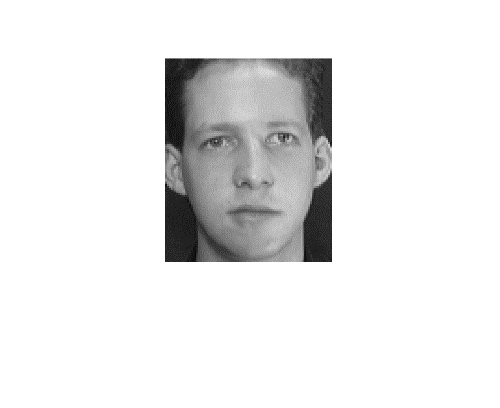

2.1- PCA analysis

a. t image:

ps5-2-1-a.png

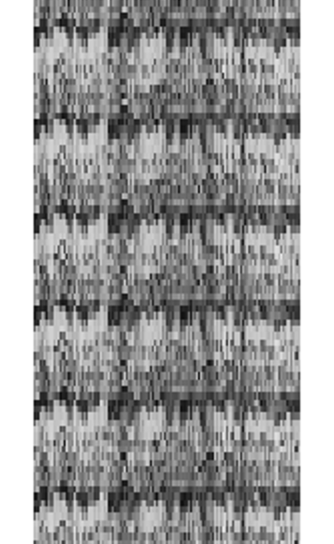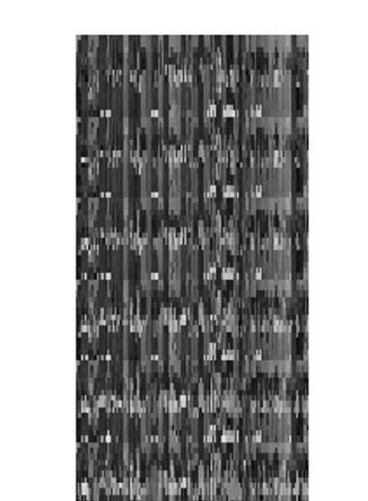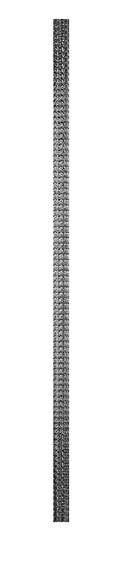

b. The mean face is difficult to distinguish because of the blurriness as well as the slight overlap between different locations of various peoples features averaged together.

ps5-2-1-b.png

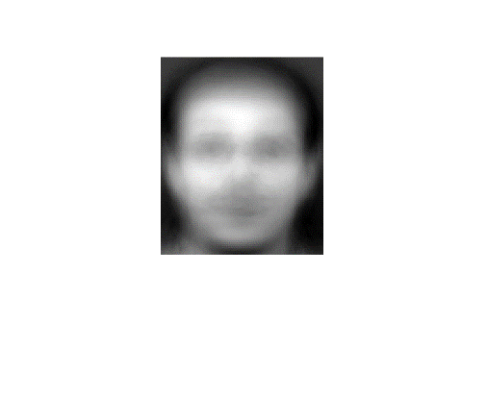

c. covariance matrix:

ps5-2-1-c.png

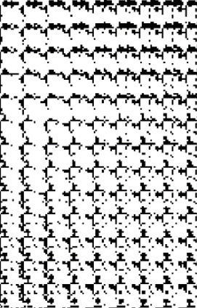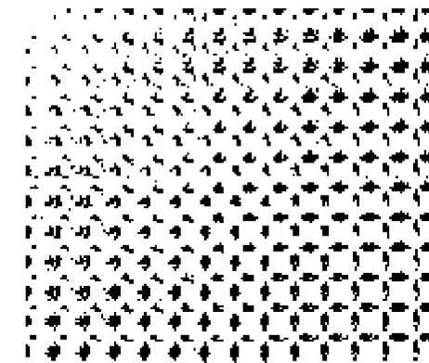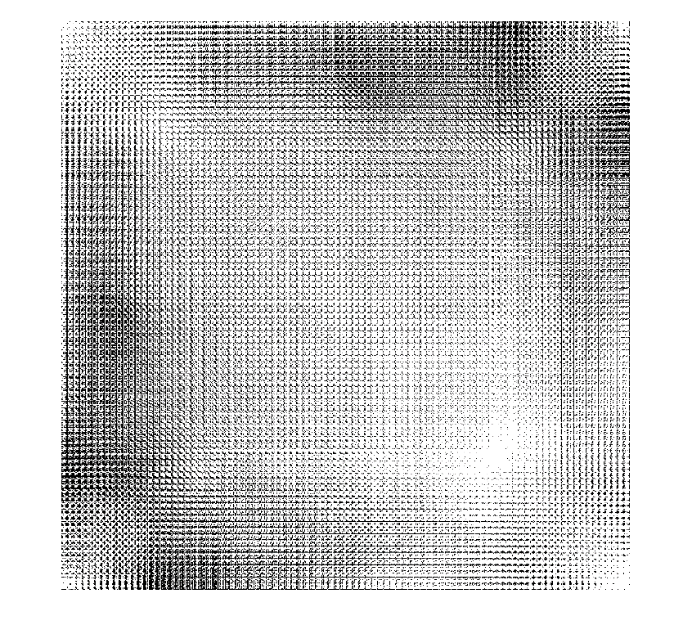

d. Number of eigenvectors that capture 95% variance is 162.

ps5-2-1-d.png

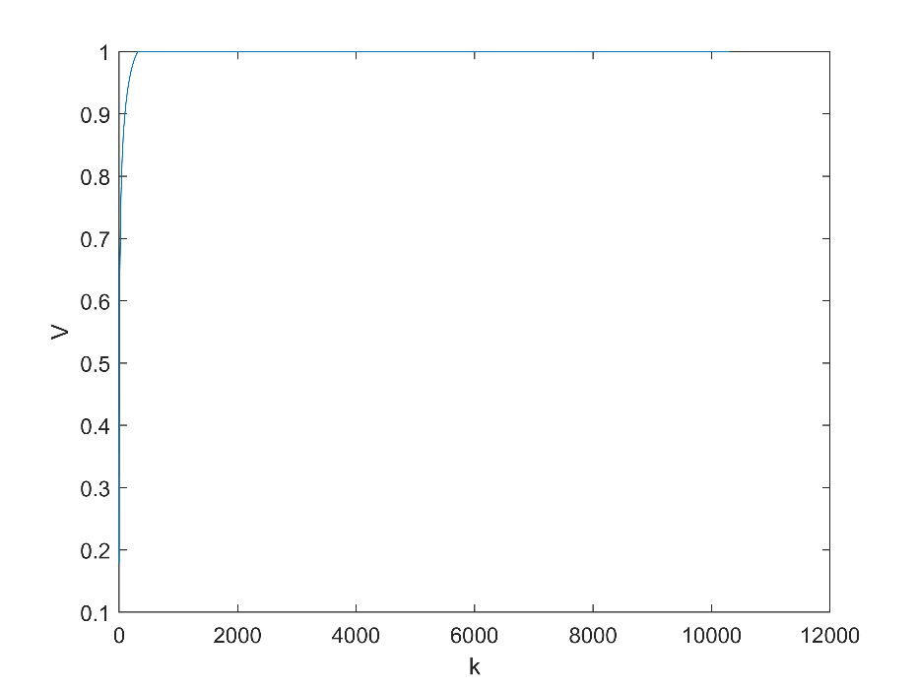

e. Dimensions of matrix U: 10304x162. These faces seem much more distorted than the mean face. This makes sense since it is the vectors that carry the most variance.

Ps5-2-1-e.png

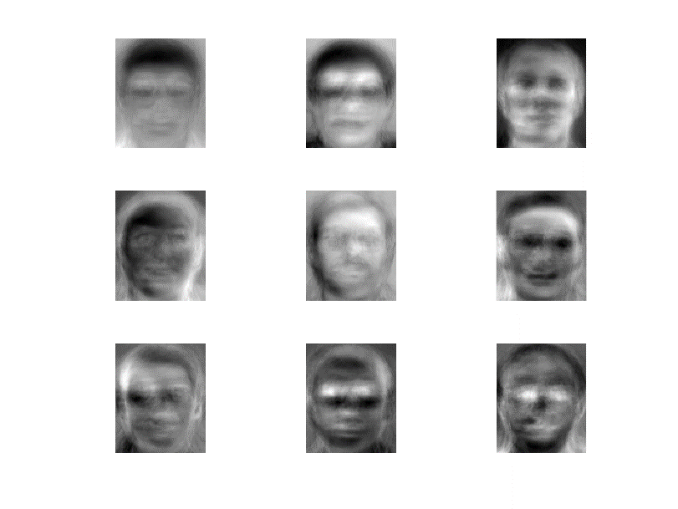

2.2- Feature extraction for face recognition

Dimensions:

W_training: 320x162

W_testing: 80x162

2.3- Face recognition

a. The accuracy decreases as the value for k increases from 1.

|  |  |  |  |  |  |  |
| --- | --- | --- | --- | --- | --- | --- |
| K | 1 | 3 | 5 | 7 | 9 | 10 |
| Accuracy | 0.9750 | 0.9625 | 0.9375 | 0.8375 | 0.8250 | 0.8125 |

b. Based on the data, overall it seems like one vs all with a linear kernel is the best approach because not only is it the fastest but also most accurate. Overall, one vs one has a smaller training time but this is due to the major outlier in the one vs all approach with a polynomial kernel. All other kernel methods yield a shorter training time for one vs all. The overall accuracy of one vs all is higher relatively to one vs one for each kernel. The rbf kernel seems to yield a very low accuracy compared to the other kernel methods. For this problem, the most accurate knn classifier is more accurate then the most accurate svm classifier.

Table 2.3.b.1 Training time for each model

|  |  |  |
| --- | --- | --- |
|  | One vs one | One vs all |
| Linear | 5.0116 seconds | 0.5910 seconds |
| Polynomial | 4.8523 seconds | 131.3726 seconds |
| RBF | 4.8234 seconds | 0.4990 seconds |

Table 2.3.b.2 Testing time for each model

|  |  |  |
| --- | --- | --- |
|  | One vs one | One vs all |
| Linear | 0.5413 seconds | 0.0615 |
| Polynomial | 0.5448 seconds | 0.0405 |
| RBF | 0.5364 seconds | 0.0483 |

Table 2.3.b.1 Accuracy for each model

|  |  |  |
| --- | --- | --- |
|  | One vs one | One vs all |
| Linear | 0.6375 | 0.9125 |
| Polynomial | 0.1375 | 0.7250 |
| RBF | 0.0500 | 0.0875 |

3- Case study

I would use a model with features describing each rest-stop across the highway such as average daily traffic count, number of nearby attractions such as restaurants, population, and miles to nearest town. I would use these features because intuitively, I would think it would make most sense to place the electric chargers in a high traffic rest stop or gas station with more attractions nearby to enjoy while charging as well as a short commute to a nearby town with a higher population.